# REPORT GENERATOR

## Document name format

### PDF

Pdf files don’t need any specific name format.

### Other

For the program to know where to append certain files it needs that information in the name off the file. Files must be formatted like:

Program splits every name by character ‘#’ and makes a list that contains strings:

## Adding categories

To add a category, you need to add variables to the template file. It should look something like this:

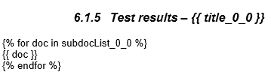

Slika 1 template example

For every template added it must have different “_0_0” part. The program will index it itself. Numbers must match the program output. Index numbers are the same for the list and the title of a file or files in the category/subcategory.

## Program structure

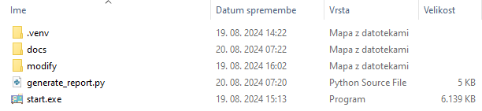

Figure 1 program directory

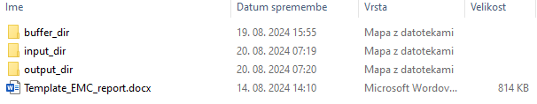

Figure 2 modify directory

* buffer_dir
  + Used for temporary saving converted files from ‘input_dir’. It should be always empty.
* input_dir
  + Files in this directory will be added to main report file. RTF files will be converted into DOCX files and then appended in. After running the program this directory will be emptied.
* output_dir
  + All generated report will be stored here. All will have distinct name, time stamp.
* Template_EMC_report.docx
  + Program uses this file as template for appending input content. This the most important file and must be modified right for program to append content in right place.

## Program

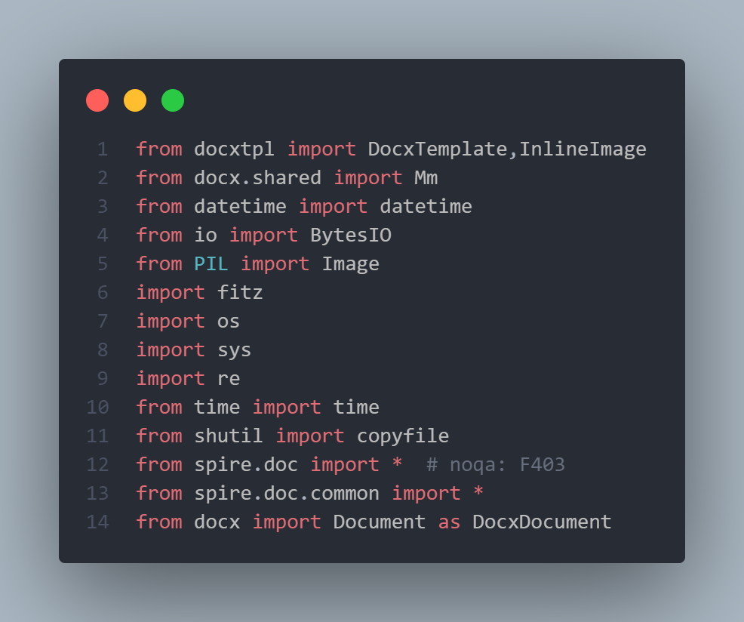

Slika 2 Imports

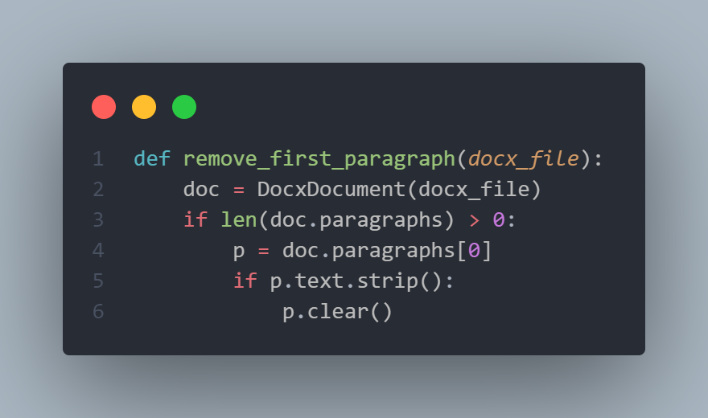

Slika 3 function for removing spire.doc stamp

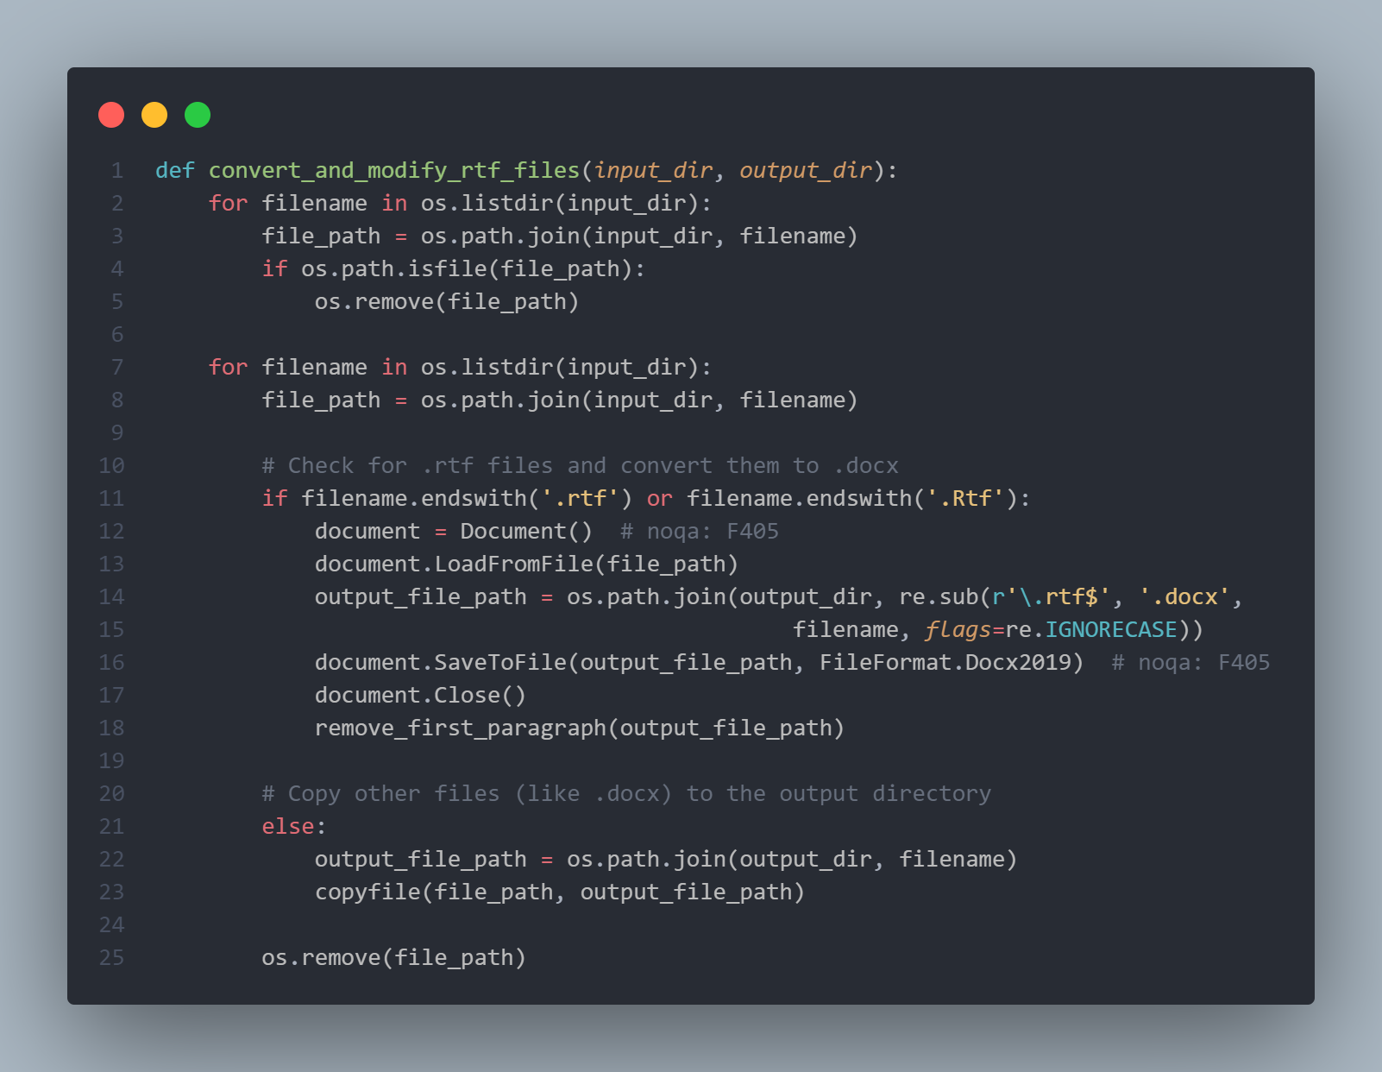

Slika 4 function for converting rtf->docx

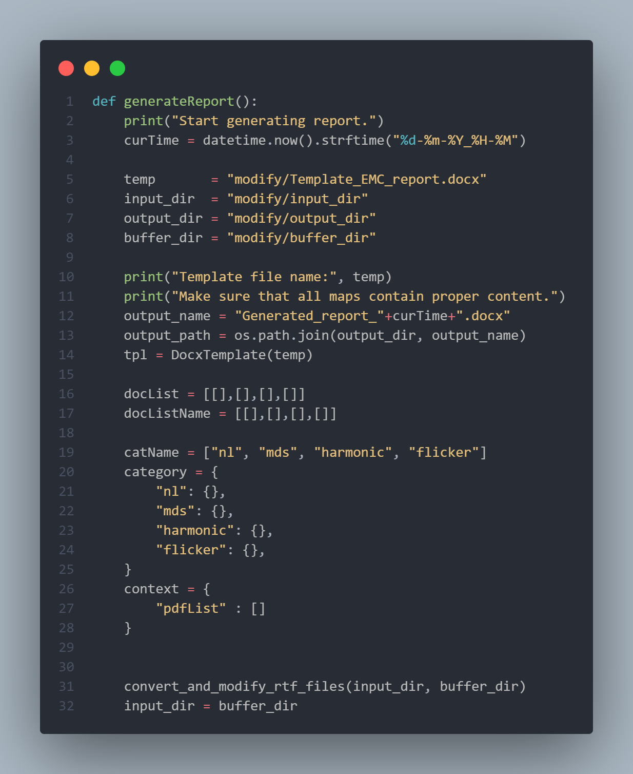

Slika 5 setup faze

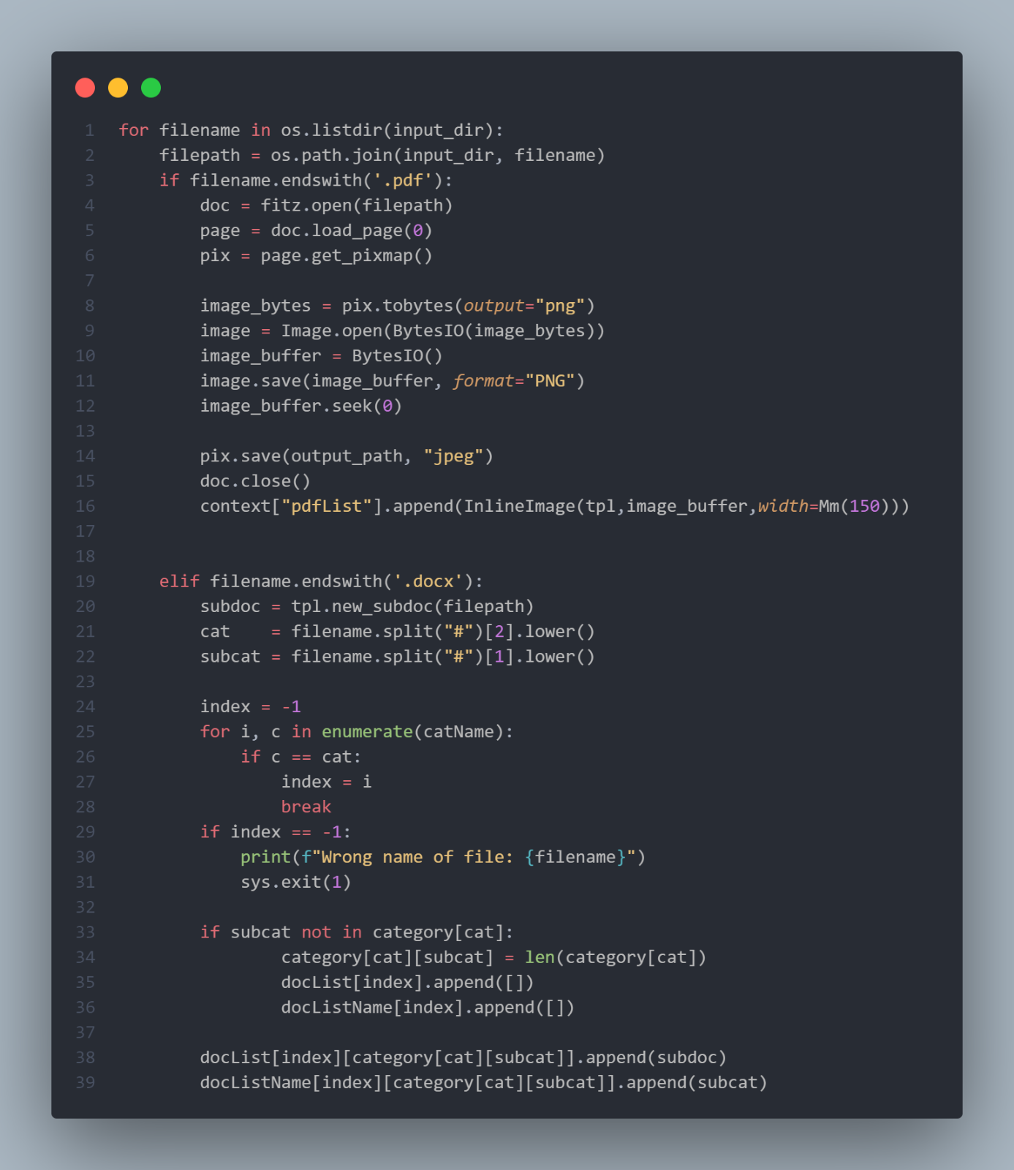

Slika 6 main faze

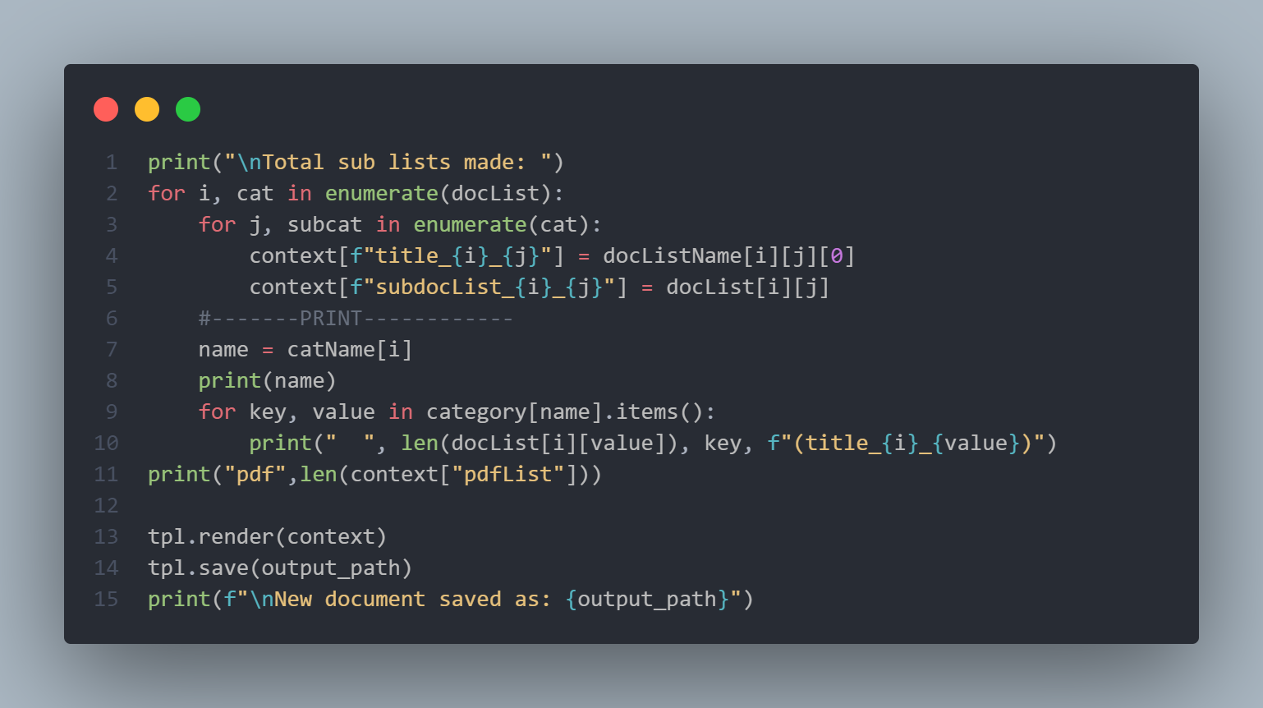

Slika 7 final faze

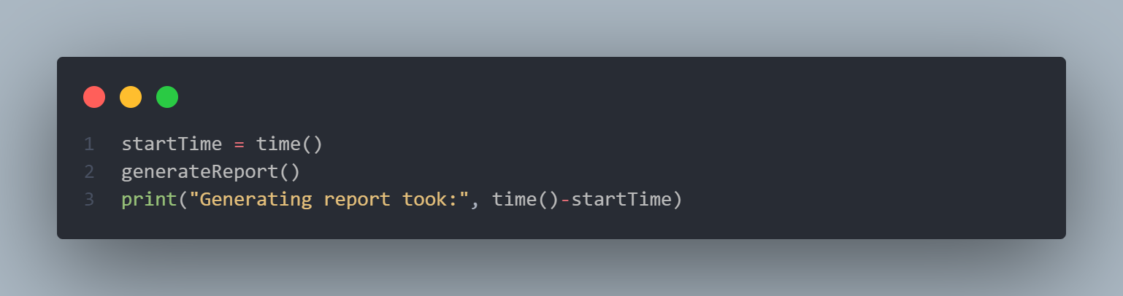

Slika 8 time stamp